A typhoon is a tropical storm in the regions of the Pacific of indian oceans. Typhoon is formed by it starting off as tropical thunderstorms. The strong winds pull in moisture from the oceans. The thunderstorms convert the moisture into heat. The heat causes more air to flow to the center of the storm which causes more evaporation. All the heat and air flow toward the eye creating the typhoon. Hurricanes, cyclones, and typhoons are all the same weather phenomenon; we just use different names for these storms in different places. In the Atlantic and Northeast Pacific, the term “hurricane” is used.

Typhoon Haiyan is one of the most powerful typhoons to ever happen and it took place in the Philippines. This typhoon left mass destruction throughout the Philippines and the death toll is supposedly exceeding 1,000.
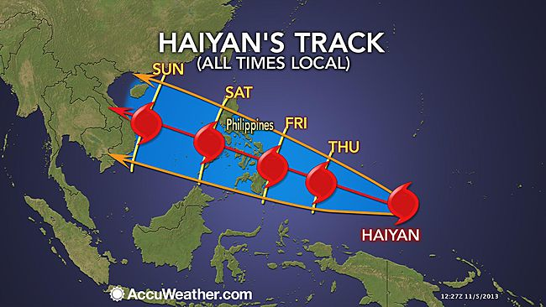
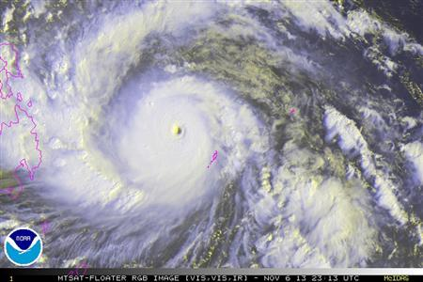
http://www.npr.org/2013/11/11/244572227/why-typhoon-haiyan-caused-so-much-damage

Typhoons are common in places in the Eastern Pacific area but Haiyan was more powerful for many reasons. Sometimes typhoons will reach its intensity right as it is making landfall and for typhoon Haiyan, that was the case. As Haiyan was reaching landfall it pushed into a bay and reached a 13 foot storm surge. Also, during the storm mountains brought tons of rainfall throughout the islands so they were hit with winds, a surge and tons of rainfall.

http://www.nbcnews.com/science/typhoon-haiyan-pushed-limit-bigger-storms-are-coming-2D11577486
Experts say Typhoon Haiyan was about as strong as it could theoretically get when it swept through the Philippines, killing thousands of people and driving hundreds of thousands from their homes. Haiyan's winds reached a sustained peak as high as 195 mph shortly before it made landfall, with gusts rising to 235 mph. They say that the winds of this storm were higher than hurricane Katrina’s. Officials are saying that powerful storms like this are going to become more common within the years due to rising climates.

